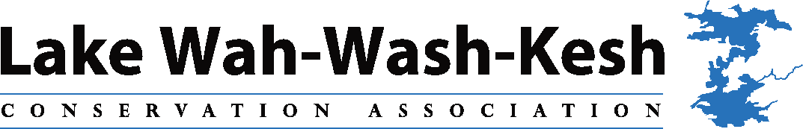

Lake Plan Taskforce Terms of Reference
Mandate:

The Taskforce’s purpose is to develop a Lake Plan, including a detailed action Plan, consistent with the priority identified in the Association’s Strategic Direction.

Goals:

There are three goals of the Association that have relevance to the committee, as follows:
- To be good stewards of the Lake and its shores
- To take a broader watershed view with respect to environmental sustainability and have a strong voice in watershed plans
- To monitor and adapt to the impacts of climate change

Accountability:

The Taskforce will be responsible to the Lake WahWashKesh Conservation Association Board of Directors for achievement of its goals. The Taskforce will conduct its operations consistent with established Board policies.

As well, the Taskforce will liaise regularly with the Land Use Planning and Development Committee to ensure exchange of information to maximize the efficiency and effectiveness of their operations and to align their work.

Deliverables:

The specific deliverables related to the development of a Lake Plan are as follows:

- Develop a lake plan that will guide future conservation and stewardship of the lake. The plan should encompass the physical, environmental, social/cultural and economic aspects of the lake.

The Lake Plan will lay out the key issues/concerns for the lake based on a resident survey, community consultations and the science/evidence. As well, an action plan will be developed for the short, medium and. long term which will address the identified issues.

- Ensure that the lake plan integrates possible measures to adapt to the impacts of climate change.

- Work collaboratively with other Lake Associations, the Land Use Planning and Development Committee and other key partners to develop the Lake Plan and seek approvals.

- Ensure that plan development is inclusive and reflects the diversity of interests in the Lake WahWashKesh community

- Ensure an open and consultative process for development of the plan, including a survey and community consultations/workshops

- Communicate regularly with the Lake Community throughout the development process so that members are aware of the status and how they can contribute.

- Ensure an ongoing mechanism for monitoring and reporting on the plan, related to accomplishments as well as necessary modifications to reflect changing circumstances and regulatory environments.

Composition:

The Taskforce will be comprised equally of members from the Top Lake and Big Lake, as well as a representative from the Narrows, to ensure appropriate representation and in recognition of the unique characteristics.

The Chair of the Taskforce will be either a Director of the Association or a member volunteer. In the case of a member volunteer assuming the role of Chair, an Association Director will be a member of the Taskforce.

Members with a strong interest in developing a Lake Plan/protecting and improving the natural environment of the Lake are encouraged to participate. As well, WWKCA members with knowledge or expertise in one or more of the following areas would be an asset:
- Environmental Sciences
- Other Science related backgrounds
- Evidence Based Research/statistics
- Community engagement/facilitation
- Government relations
- Climate Change

